Logging in

1.
Which of the following statements are things that you should do when using computer equipment and which are things that you should not do?
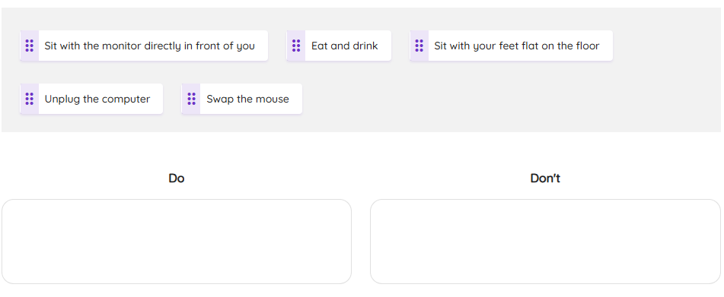

2.
Which of the following will help to ensure you are using a strong password?
- Use a long word from the dictionary
- Use your date of birth
- Use the name of your favourite team
- Use your best friend’s name
- Use a minimum of 8 characters
- Use numbers and symbols such as @
- Use upper- and lower-case letters
3.
- What is a computer network?
- A set of instructions that a computer follows precisely
- A collection of digital devices that are connected together
- A group of people that know each other
- An online system that stores digital resources
4.
True or false? You usually need a username and password to log in to a computer network.
- True
- False

File management, cloud computing and VLEs
1.
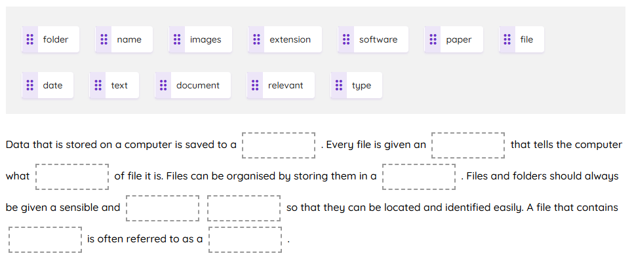
Drag and drop the correct words to complete the sentences.

2.
Match the file extension to the file type.
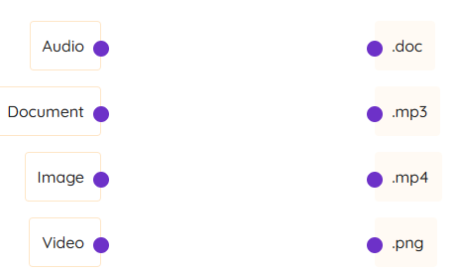
3.
Which of the following are advantages of cloud computing?
- Your data will be backed up automatically.
- You don’t need an internet connection to access your data.
- The software will always be the latest version.
- You can pay for extra storage space if you need it.

The internet and digital wellbeing
1.
Which of the following are things that you should use the internet for at school and which are things you should not use the internet for at school?"
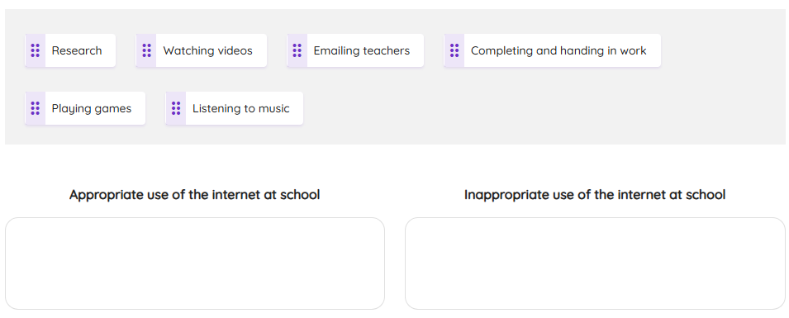
2.
Answer the following true or false questions.

True or false? All information on the internet is trustworthy.
- True
- False

True or false? All websites written by specialists are biased.
- True
- False

True or false? When researching something on the internet, you should get your information from more than one unrelated source.
- True
- False

3.
Answer the following true or false questions.
True or false? Too much time spent online can affect your health.
- True
- False

True or false? Too much time spent online can affect your performance at school.
- True
- False

True or false? Too much time spent online can affect your friendships.
- True
- False

4 Vector graphics
1.
Drag and drop the correct words to complete the sentences.
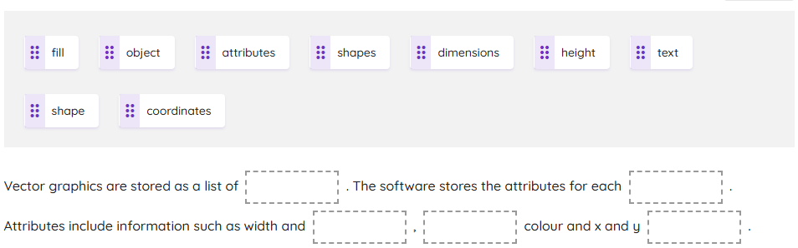

2.
Answer the following true or false questions.
True or false? Vector graphics lose quality when they are scaled.
- True
- False

True or false? Vector graphic files are usually large.
- True
- False

True or false? Vector graphic objects can be layered.
- True
- False

True or false? .eps and .pdf are file extensions for vector graphic files.
- True
- False

True or false? In a vector graphic, the shape of an object is stored as a set of points that are joined together by lines.
- True
- False

Bitmap graphics
1.
Drag and drop the correct words to complete the sentences.
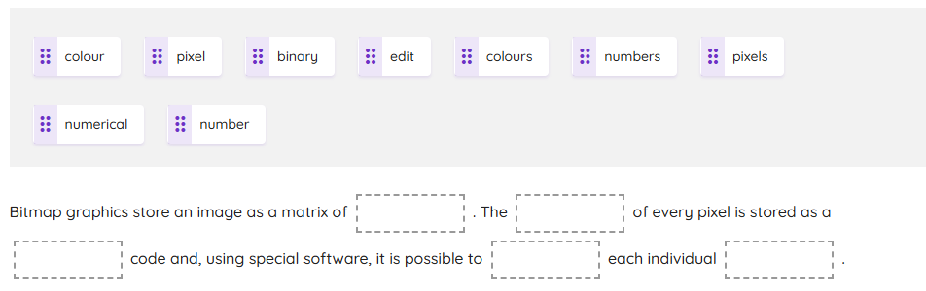

2.
Answer the following true or false questions.
What are bitmap graphics also known as?
- Vector graphics
- Raster graphics
- Image graphics

What is the resolution of an image?
- The size of an image
- The number of different colours in an image
- The number of pixels in an image

Are bitmap graphic files usually large or small?
- Large
- Small

What happens when a bitmap image is enlarged?
- The quality improves
- The quality stays the same
- The quality gets worse

3.
Which of the following are extensions for vector graphic files and which are extensions for bitmap graphic files?

